Milestone 3:
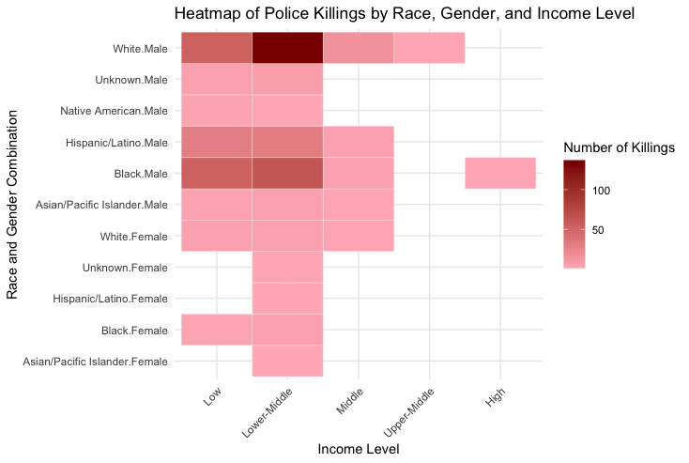

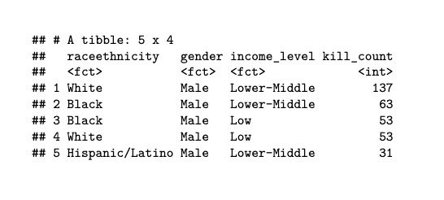

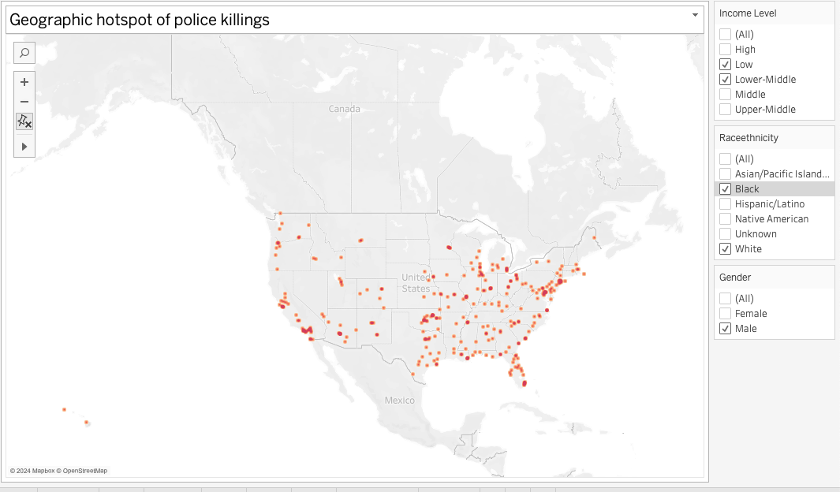

Observations: This analysis begins with a heatmap that reveals high-risk profiles by visualizing the relationship between race, gender, and income levels. The y-axis represents combinations of race and gender, while the x-axis displays income levels, allowing us to identify profiles with the highest police killing counts. To further explore these patterns, an interactive Tableau dashboard is created featuring a chloropleth density map that displays the top five high-risk profiles geographically. This dashboard enables dynamic filtering, allowing users to examine how race, gender, income, and location intersect to contribute to elevated risk levels across regions.

